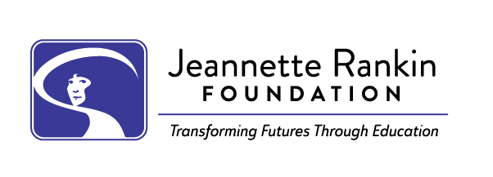
PLEASE DO NOT ATTACH THIS DOCUMENT TO YOUR APPLICATION. COPY AND PASTE YOUR ANSWERS INTO THE JRF ONLINE APPLICATION FORM.

To help prepare your JRF application submission, we recommend writing and saving your essay responses within this Word document or a Google document. When your responses are proofed and complete, you can easily copy and paste them into your JRF online application.

Personal Statement
The Personal Statement will help us learn about your life as well as your academic and career goals. This is a very important part of the application, so please take your time. Be sure to address each of the following four topics thoroughly. Write approximately 200-400 words per question.

Question 1: What are your academic and career goals? Describe your goals and tell us your plan for meeting them.

Question 2: How will your education benefit yourself, your family, and your community?
The benefit to your community can be in any capacity, including as a volunteer, as a mentor, or directly through your career.

Question 3: Which of your accomplishments makes you the proudest?

Question 4: How have your life experiences, family, employment, and volunteer work contributed to your present goals and/or challenged your ability to reach these goals? Comment on, for example, child-rearing, homemaking, eldercare, or illness, as well.

